***THE 2025 RUSSIAN RIVER***

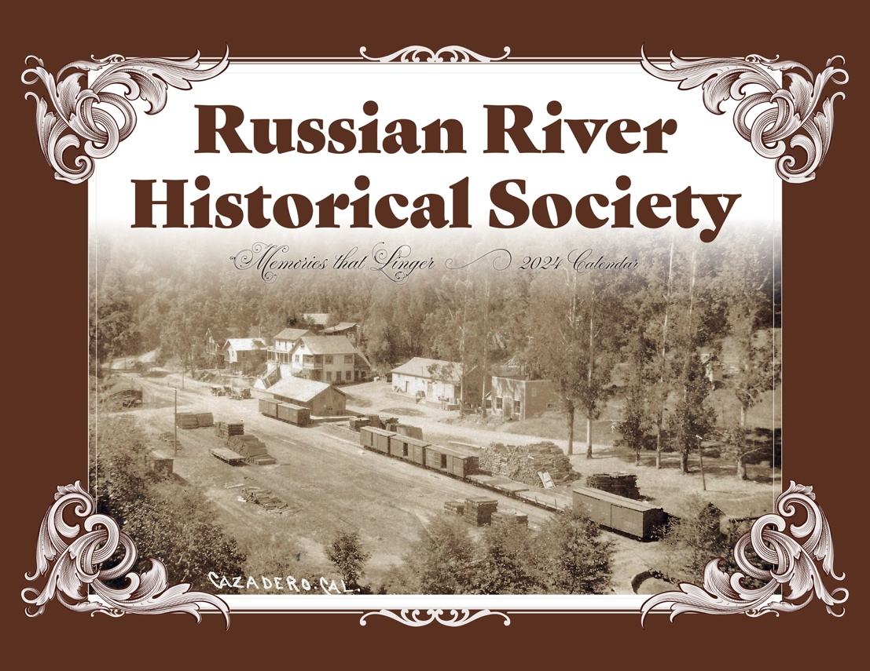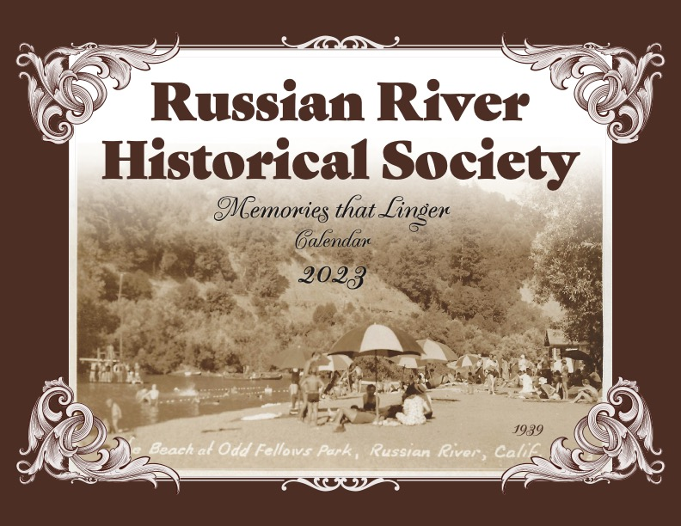***HISTORICAL CALENDAR***

***Travel back in time with the Russian River Historical Calendar Memories That Linger.***

***Each month features digitally restored historic images and historically significant***

***events from times past.***

***Proceeds benefit the Russian River Historical Society***

***$15.00 + $5.00 SHIPPING & HANDLING EACH***

***------------------------------------------------------------------------------------***

***Pre-Order Form:***

***Mail to: P.O. Box 484, Monte Rio, CA 95462***

***Name: ____________________________________________________________***

***Shipping Address: __________________________________________________***

***City:_______________________________ State:__________ Zip: ___________***

***Phone: ______________________Email:________________________________***

***# of Calendars:______x $15.00 = $______***

***+ Tax EA= $1.02 = $______***

***+ $5.00 EA= $__________***

***Total Enclosed: $___________***

***Thank you for your support!***